11. Orientation of a Palaeo Stress-Ellipsoid (Dihedra Method)
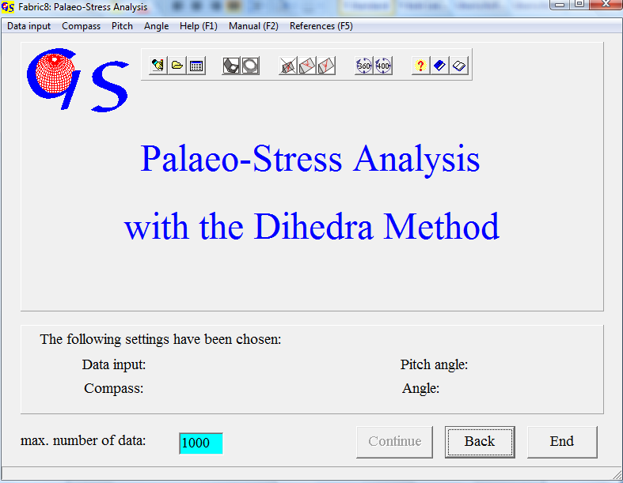
Fig. 1

This program (Fig. 1) calculates the orientation of the three principal stresses σ1> σ2> σ3 from the orientation of slickenside planes and striations on them. The polarity of the striation lineation (hanging block up or down) must be clearly defined in the field. The algorithm which was developed according to the method of ANGELIER & MECHLER (1976) works as follows: An auxiliary plane is constructed normal to the slickenside plane and normal to the striation. Both, slickenside plane and the auxiliary plane divide the globe into a compressional dihedron which must contain σ1, and in a tensional dihedron which must contain σ3 (Fig. 2).
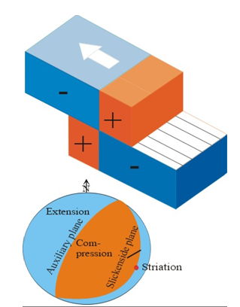
Fig. 2

The intersecting set of all compressional dihedra is calculated and plotted with the contour lines of 20%, 40%, 60%, 80% und 95% of compression. The liability of the method is controlled by two things:
- the shear sense on the slickenside plane must be doubtlessly determined. 2. the slickenside planes should have very different orientations. This reduces
the size of the intersecting set which contains σ1.

The menus „Data input“, “Compass“, and “Angle“ are the same as in programme 3.
Input of the orientation of the striation lineation can also be given as pitch angle on the slickenside plane. In this case the direction – clockwise or counter clockwise – must be chosen in the menu "Pitch". Click on “No” when no pitch angles are used. (Fig. 3).

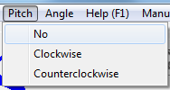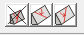
Fig. 3

The form for manual input of Clar compass data compass (Dip azimuth and angle of dip of the Slickenside and the striation) is shown in Fig. 4.
After pressing "Start" the orientation of the slickenside plane must be filled in, followed by the orientation of the striation.

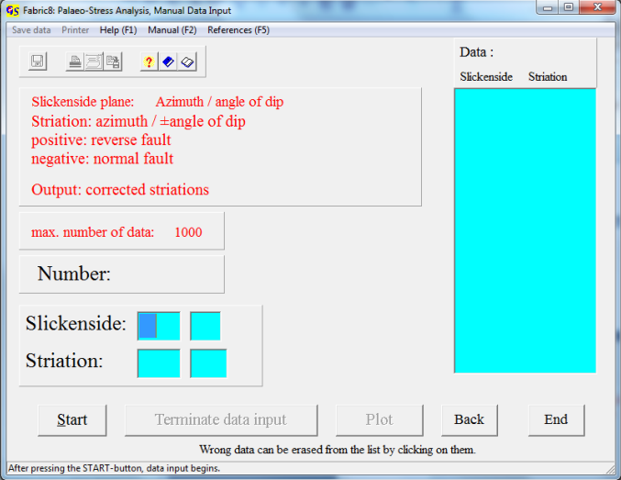
Fig. 4

Fig. 5 shows the input fields for the Brunton compass (Strike, dip and direction of dip). Fig. 6 shows the the input field for ‘plane and pitch angle’ data.
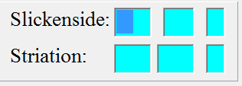
Fig. 4
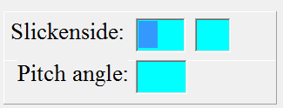
Fig. 5

The dip angle is positive for reverse faults and negative for normal faults. For positive dip angles the sign '+' is not necessary. The orientation of striations is corrected automatically, so that the striation is always put in the slickenside plane, even if their are small measure errors.
Input from a file is the same as in the previous programs.

The graphic form is shown in Fig. 6

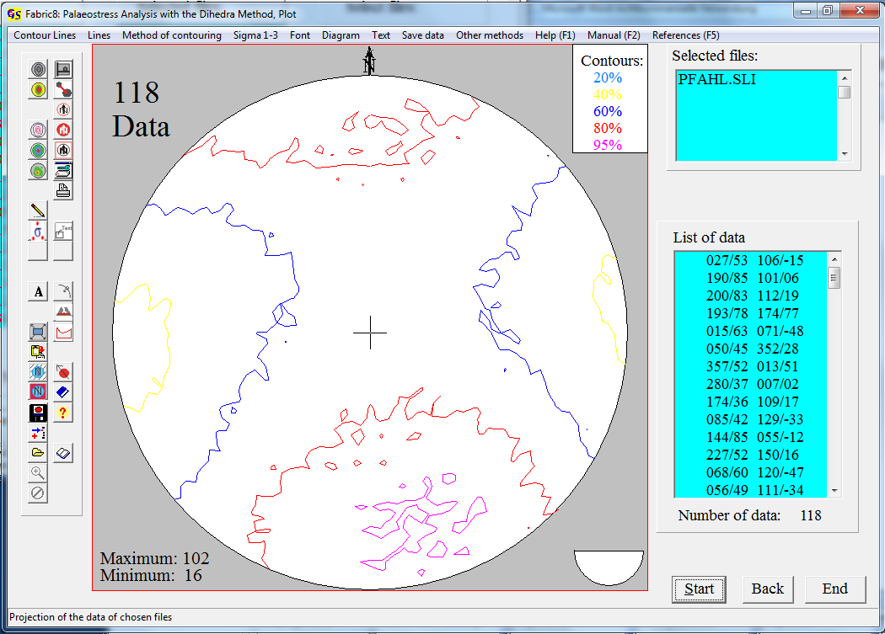
Fig. 6
In the menu “Contour lines” (Fig. 7) the colours of contour lines can be changed.
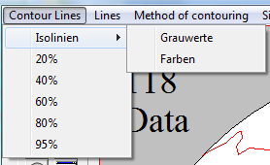 Fig.7

Contours can be plotted either in a scale of gray or in colour.

The applied algorithm works with the methods of set theory. That means that the exact position of σ1 in the 95%-contour cannot be defined. σ3 is situated in the lowest contour. The minimum number of data (in the extensional dihedra) is a measure for the quality of the data set. A consistent data set should have a minimum of zero.
With the Menu “Sigma 1-3” (Fig. 8) the estimated principal stresses σ₁ and σ₃ can be plotted into the diagram by mouse click.

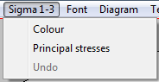
Fig. 8

Click on “Colour” to choose the colour of the points then click on “Principal stresses” then click on a point in the diagram which represents the estimated direction of one principal stress, afterwards click press on the corresponding button (Fig. 9).

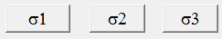
Fig. 9

Since the principal stresses are normal to each other, a great circle around the chosen point is drawn. Now click on a point on the great circle which represents another principal stress direction and press the corresponding button. Another great circle is plotted. Now click on the point of intersection of the two great circles and press the remaining button. After this the graphic will be built up again and the three principal stresses are shown. Their values appair on the right side (Fig. 10).
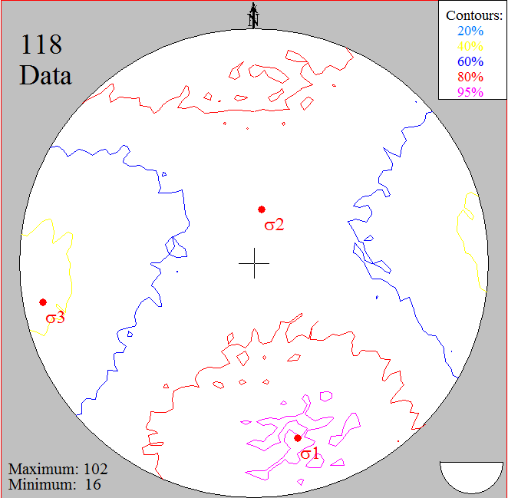
Fig. 10

In addition to the vectorgraphic (Fig. 6) you also have the option of plotting a pixel graphic (bitmap) which gives very smooth contours. The method is explained in program 8 (Contour lines). With the option “Distance Method” of the menu “Method of contouring” (Fig. 11) the transition between the contours can be chosen in steps (Fig. 12) or floating (Fig. 113). The choice of colours for the floating modus is described in program 8. With the option “Calotte” you return to vector graphics (Fig. 6).

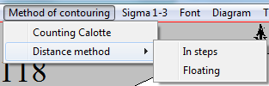 Fig. 11

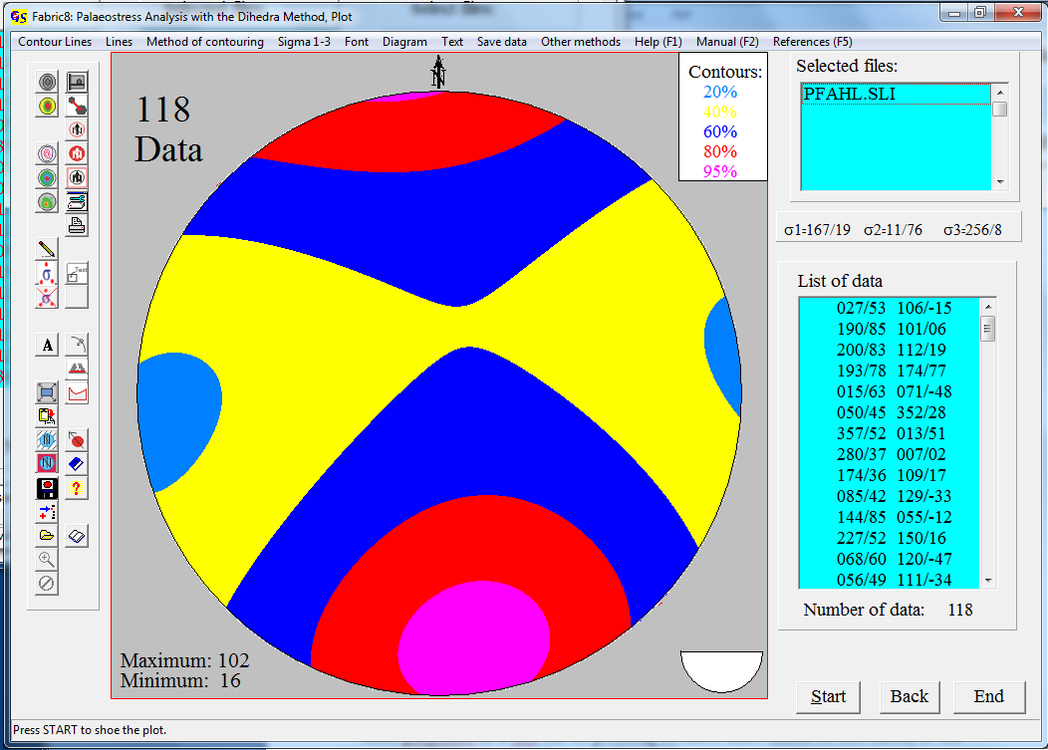 Fig. 12
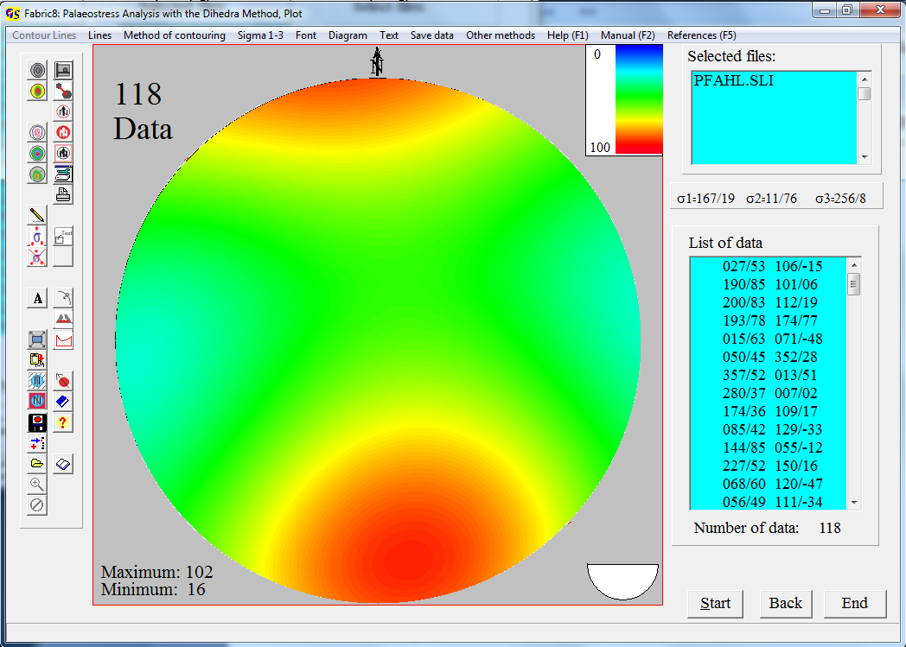
Fig. 13

The menu "Diagram" is described in program 3.

With the menu "Other methode" (Fig. 11) you jump to the other programs which also use displacement data.

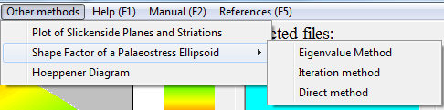
Fig. 11

